|  |  |
| --- | --- |
| **EX NO: 3** | **EXAM REGISTRATION SYSTEM** |

***USE CASE DIAGRAM:***

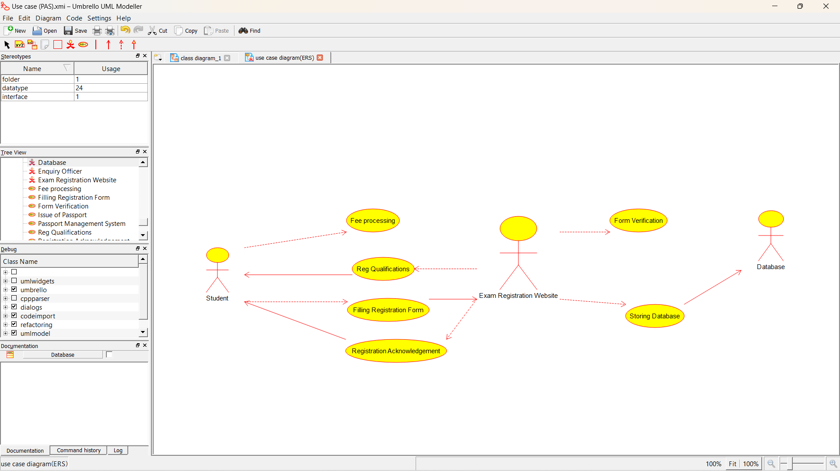

***CLASS DIAGRAM:*** 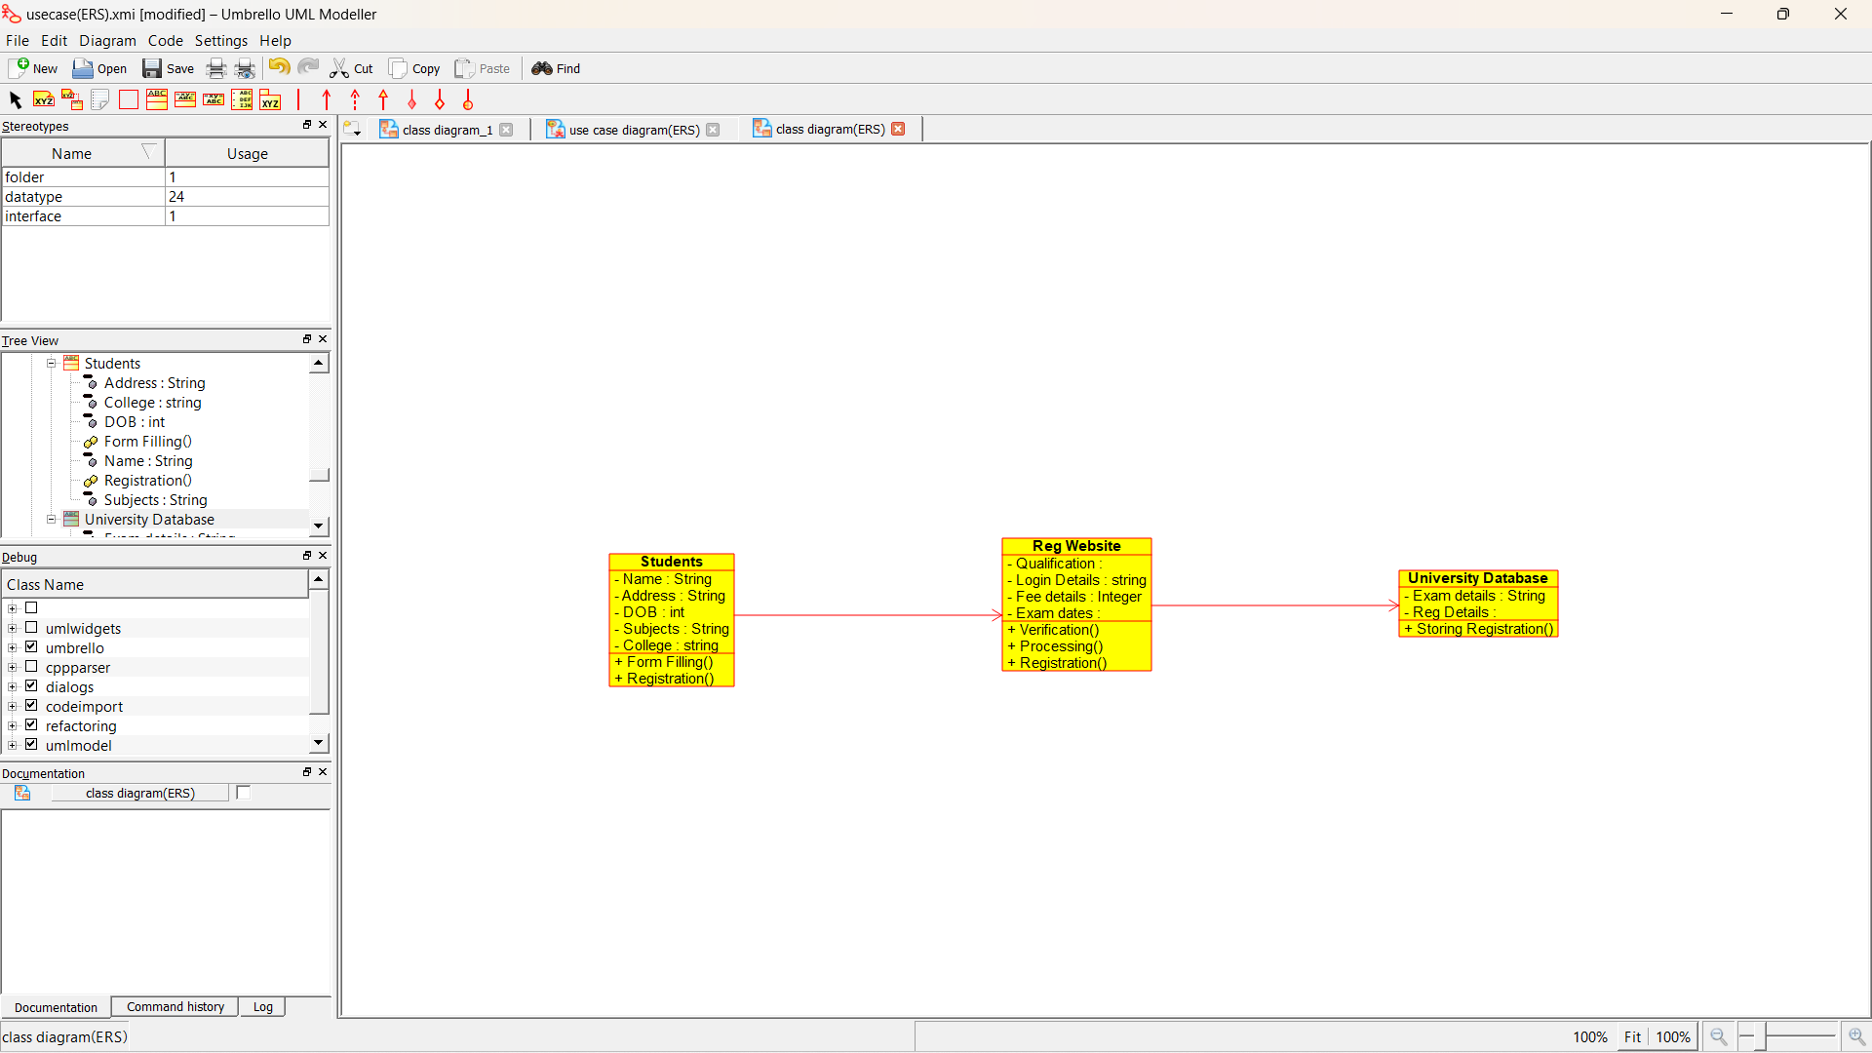

***ACTIVITY DIAGRAM:***

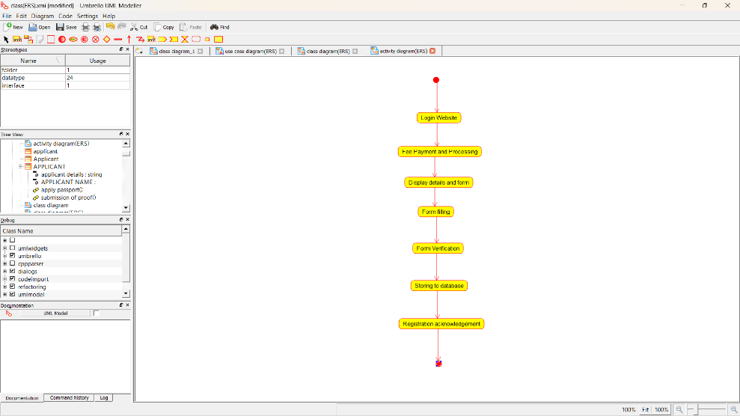

***SEQUENCE DIAGRAM:***

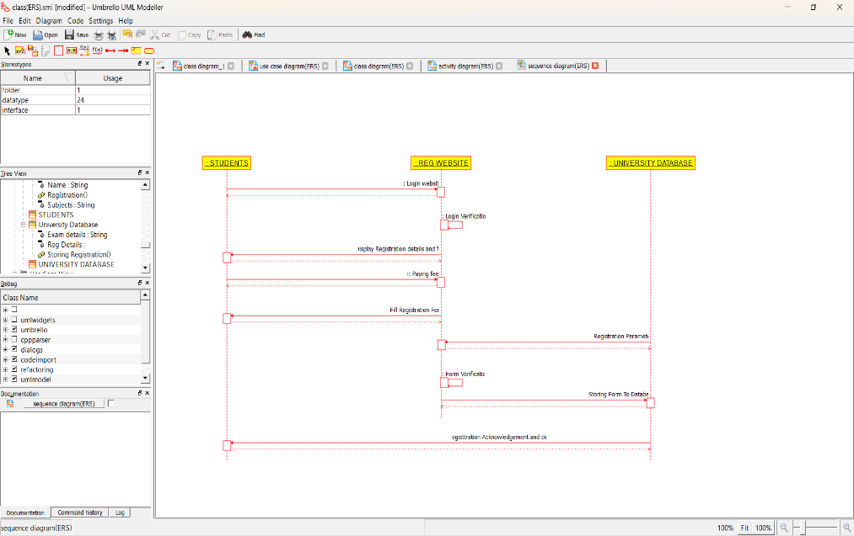

***COLLABORATION DIAGRAM:***

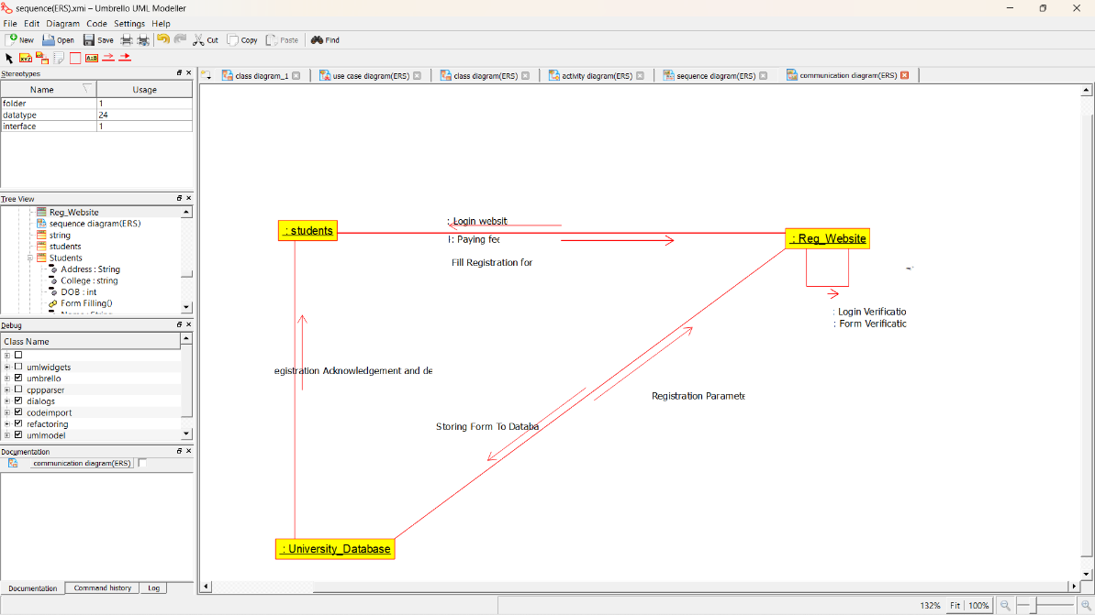

***STATE DIAGRAM:***

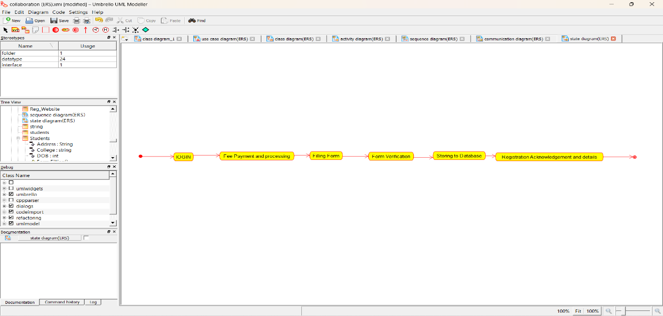

***COMPONENT DIAGRAM:***

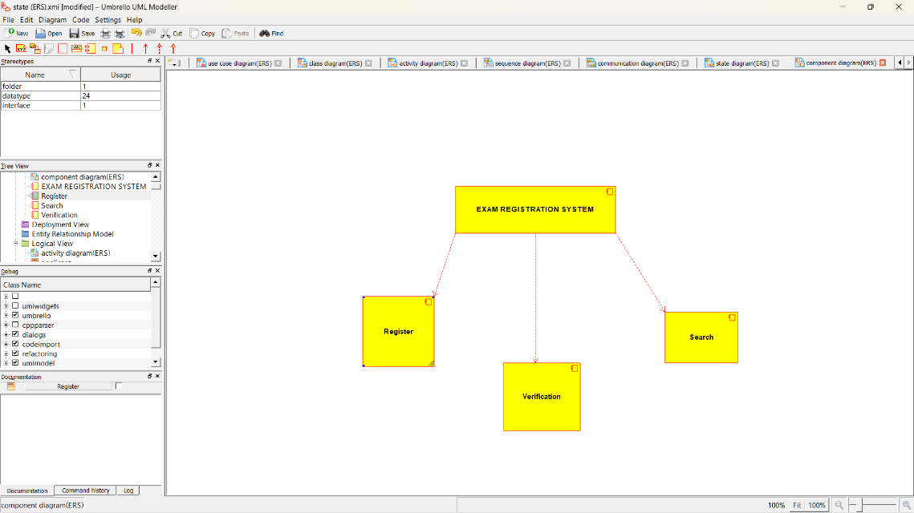

***DEPLOYMENT DIAGRAM:*** 